**CG-Assignment**

**Liang Barsky Line Clipping Algorithm**

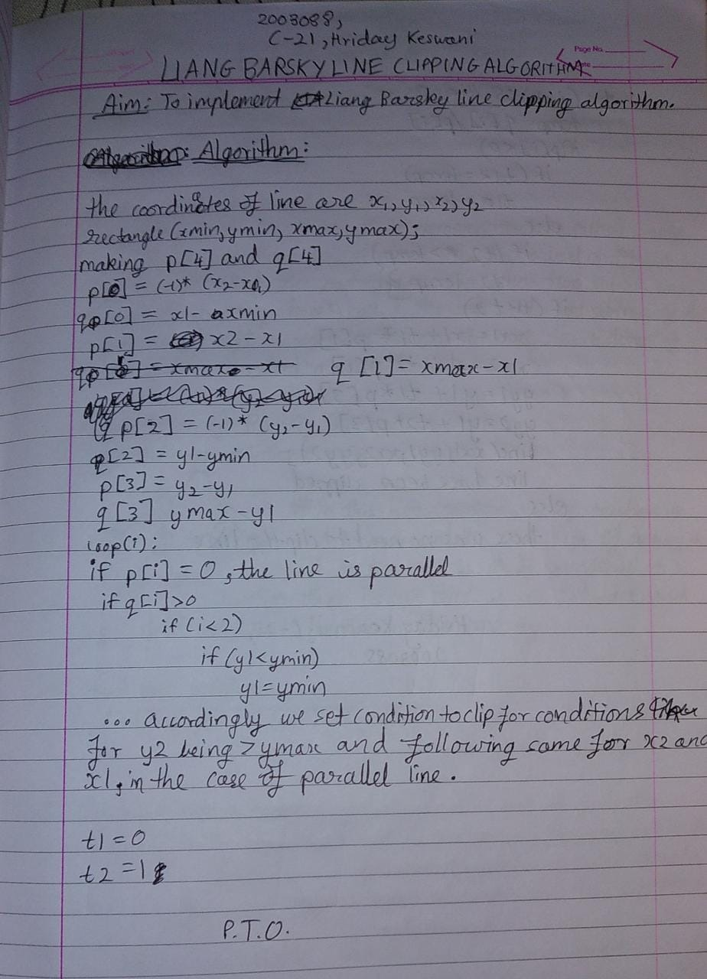

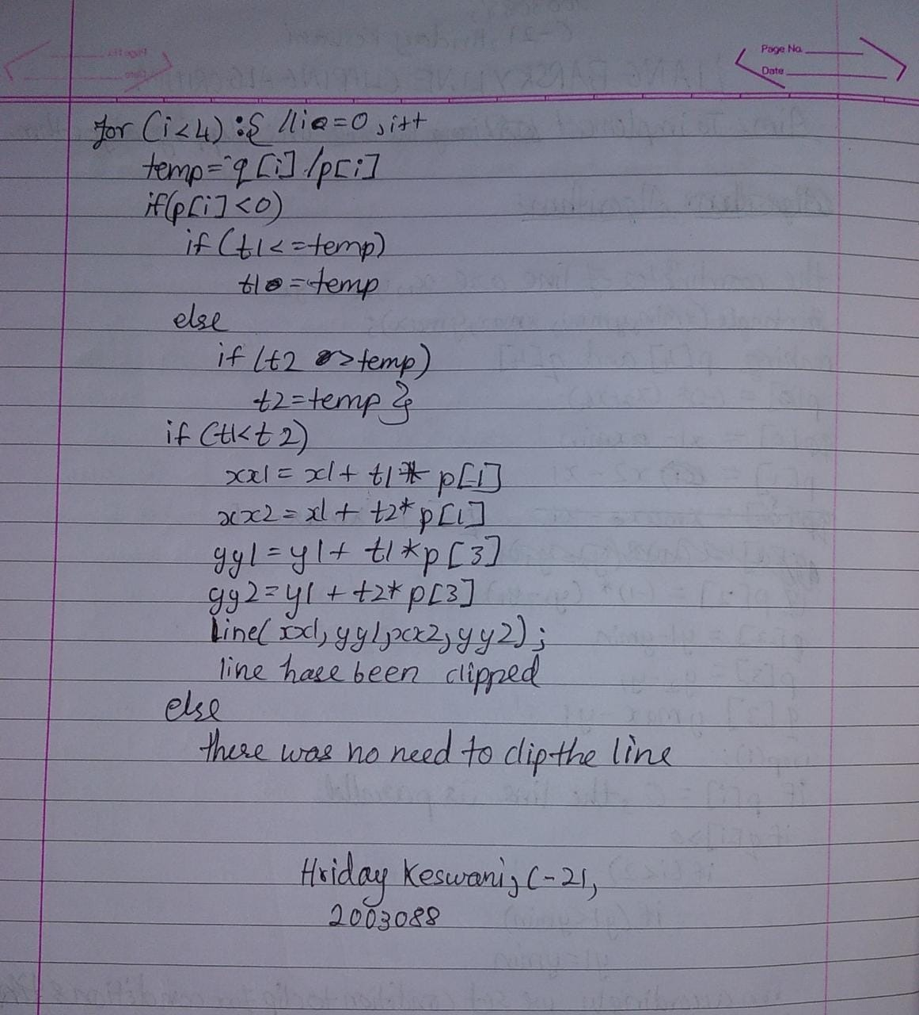

**Program:**

Implementing Liang Barsky line clipping algorithm in C

**Code:**

#include<stdio.h>

#include<conio.h>

#include<graphics.h>

#include<math.h>

void main(){

int gd = DETECT, gm;

int x1,y1,x2,y2,xwmin,ywmin,xwmax,ywmax,i;

int xx1,yy1,xx2,yy2,status;

float t1,t2,p[4],q[4],temp;

initgraph(&gd, &gm, "C:\\TURBOC3\\BGI");

printf("Enter the coordinates for line:(xmin = ymin = 100, xmax = ymax = 250)\n");

scanf("%d%d%d%d",&x1,&y1,&x2,&y2);

xwmin = ywmin = 100;

xwmax = ywmax = 250;

rectangle(xwmin,ywmin,xwmax,ywmax);

p[0] = (-1)*(x2-x1);

q[0] = x1-xwmin;

p[1] = x2-x1;

q[1] = xwmax-x1;

p[2] = (-1)*(y2-y1);

q[2] = y1-ywmin;

p[3] = y2-y1;

q[3] = ywmax-y1;

for(i=0;i<4;i++){

if(p[i]==0){

printf("Line is parallel\n");

if(q[i]>=0){

if(i<2){

if(y1<ywmin){

y1 = ywmin;

}

if(y2>ywmax){

y2 = ywmax;

}

line(x1,y1,x2,y2);

}

if(i>1){

if(x1<xwmin){

x1 = xwmin;

}

if(x2>xwmax){

x2 = xwmax;

}

}

line(x1,y1,x2,y2);

}

}

}

t1=0;

t2=1;

for(i=0;i<4;i++){

temp = q[i]/p[i];

if(p[i]<0){

if(t1<=temp)

t1=temp;

}else{

if(t2>temp)

t2=temp;

}

}

if(t1<t2){

xx1 = x1 + t1*p[1];

xx2 = x1 + t2*p[1];

yy1 = y1 + t1*p[3];

yy2 = y1 + t2*p[3];

line(xx1,yy1,xx2,yy2);

printf("Line clipped");

setcolor(6);

line(x1,y1,xx1,yy1);

}else{

printf("Line not clipped");

}

printf("\n\n\n\n\n\nHriday Keswani\n2003088\nC-21");

getch();

clrscr();}

**Output:**

